
MECHATRONIC SYSTEM INTEGRATION
MCTA 3203

WEEK 4 :
SERIAL INTERFACING WITH MICROCONTROLLER

SECTION 1
SEMESTER 2, 2025/2026

INSTRUCTOR:
ASSOC. PROF. EUR. ING. IR. TS. GS. INV. DR. ZULKIFLI BIN ZAINAL
DR. WAHJU SEDIONO

DATE OF SUBMISSION : 18 MARCH 2026
GROUP 7

NAME | NO. MATRIC
MUHAMMAD FARISH BIN AB LATIF | 2329227
MUHAMMAD FARQI SARHIDI BIN ABDUL HAFAZ | 2316461
MUHAMMAD DANISH BIN MOHD HANIFAH | 2311377

Contents

Abstract 2
Introduction 2
Materials and Equipment 2
Experimental Setup 3

Methodology 3
Data collection 4
Data Analysis 4
Results 4
Discussion 4 Conclusion 4
Recommendations 4
References 4
Acknowledgments 5
Student’s Declaration 5

Abstract
This experiment investigates the integration of multi-modal sensing and real-time data processing to create a secure, motion-based access control system. By connecting an MPU6050 inertial measurement unit and an RFID module to an Arduino, the system implements a two-step verification method that requires both RFID authentication and a predefined gesture for access approval.
The main technical aspect of the project focuses on establishing a serial communication connection between the Arduino and a Python environment, where accelerometer and gyroscope readings are analyzed to detect specific motion patterns, including circular gestures. Once the RFID tag is successfully verified and the motion pattern is identified through algorithmic processing, the system activates a servo motor to imitate the unlocking of a physical lock. This experiment highlights the practical use of sensor fusion, serial communication protocols, and Python-based signal processing in modern embedded systems and IoT security applications.

Part 1 : Interactive Motion Detection with MPU6050

Introduction
The goal is to establish a bidirectional serial connection where the Arduino constantly streams MPU6050 accelerometer data to Python. Python will analyze the data points in real-time to determine if the user is moving the sensor in a circular motion. If a circle is detected, Python will send a command back to the Arduino to toggle an LED ON or OFF.

Materials and Equipment
- Arduino board + USB cable
- MPU6050 sensor
- Jumper wires/breadboard
- 1x LED (Any color)
- 1x 220 Ω Resistor
- Computer with Arduino IDE and Python installed

Experimental setup
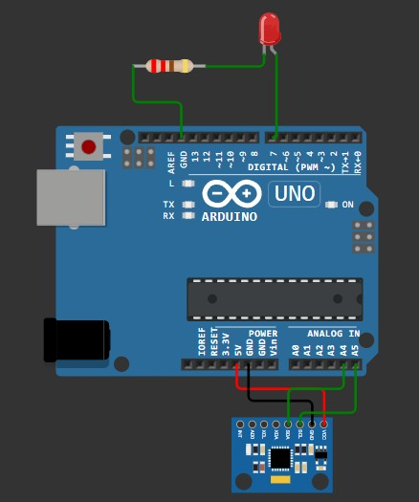
Fig. 1: Arduino-MPU6050 Connections
Connections
MPU6050 Pin | Arduino Uno
VCC | 5V
GND | GND
SDA | A4
SCL | A5
LED PIN
LED | D7
220 ohm | GND

Arduino Code:

#include <Wire.h>
#include <MPU6050.h>

MPU6050 mpu;

// --- DEFINE YOUR LED PIN HERE --- const int ledPin = 7; // Fill in
void setup() { Serial.begin(9600);
Wire.begin();
mpu.initialize();

if (!mpu.testConnection()) {
Serial.println("MPU6050 connection failed!"); while (1);
}
pinMode(ledPin, OUTPUT);
digitalWrite(ledPin, LOW); // Start with LED off }
void loop() {
// 1. Read motion data int16_t ax, ay, az, gx, gy, gz;
mpu.getMotion6(&ax, &ay, &az, &gx, &gy, &gz);

// 2. Send formatted data to Python (ax,ay,az)
Serial.print(ax); Serial.print(',');
Serial.print(ay); Serial.print(',');
Serial.println(az);

// 3. Listen for commands from Python to control the LED if (Serial.available() > 0) { char cmd = Serial.read(); if (cmd == 'O') {
digitalWrite(ledPin, HIGH); // Turn LED ON
}
else if (cmd == 'F') {
digitalWrite(ledPin, LOW); // Turn LED OFF
}
}
delay(50); // Small delay for stability }

Python code:

import serial import time
from collections import deque

# -- Replace 'COMx' with your Arduino's serial port
SERIAL_PORT = 'COM3'
BAUD_RATE = 9600

# Buffers to store the last 40 data points (approx. 2 seconds of
motion)
history_x = deque(maxlen=40) history_y = deque(maxlen=40)

def is_circular_motion(x_data, y_data): """ Analyzes an array of X and Y accelerometer data.
Returns True if the data represents a circular motion, False otherwise. """ if len(x_data) < 10:
return False

# --- STUDENTS: ADD YOUR CIRCLE DETECTION MATH HERE ---
# Step 1: Find the center (mean) of the X and Y movement.

# Step 2: Check Amplitude. Calculate the variance to ensure there
is
# enough overall movement (ignore small jitters).

# Step 3: Check Symmetry. Check the ratio of X standard deviation
to Y # standard deviation to ensure it is round, not a straight line.

# Step 4: Check Continuous Rotation. Use the 2D Cross Product
(x1*y2 - y1*x2)
# between consecutive centered points to see which way the path is turning.

# Step 5: Tally the clockwise vs. counter-clockwise turns. If the
movement # is consistently turning in one direction (e.g., > 70%), return True!

return False # Change this to return True when your math detects
a circle def main(): ser = serial.Serial(SERIAL_PORT, BAUD_RATE, timeout=1)
time.sleep(2) # Wait for Arduino to reset
print("System ready. Move the MPU6050 in a circle to toggle the
LED...")

# Keep track of the LED state
led_is_on = False

try: while True:
raw = ser.readline().decode(errors='ignore').strip() if raw: parts = raw.split(',') if len(parts) >= 3: try: ax = int(parts[0]) ay = int(parts[1])

# Add new data to our buffers
history_x.append(ax) history_y.append(ay)

# Only analyze if our buffer is full (40
points) if len(history_x) == 40: if is_circular_motion(history_x, history_y):

# Toggle the state
led_is_on = not led_is_on if led_is_on: print("Circle Detected! Toggling
LED: ON")
ser.write(b'O') else: print("Circle Detected! Toggling
LED: OFF")
ser.write(b'F') # DEBOUNCE: Clear the buffers!
# Forces the system to wait for 2
full seconds of # NEW data before it can trigger another toggle. history_x.clear() history_y.clear() except ValueError: pass # Ignore corrupted serial lines except KeyboardInterrupt:
print("\nProgram terminated by user.") finally: ser.write(b'F') # Ensure LED turns off when script stops
ser.close()
print("Serial connection closed.") if __name__ == "__main__": main()}

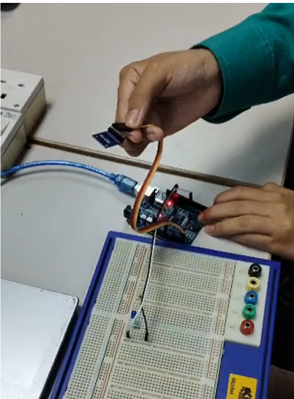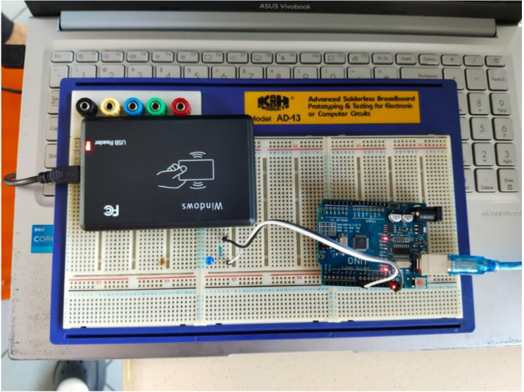

Methodology
Experiment steps:
- Build the circuit according to the experimental setup instructions.
- Upload the provided Arduino code to our Arduino Uno.
- Run the Python code in PyCharm.
- Open serial monitor on Arduino IDE
- Move the MPU6050 in a circular motion.

Data collection
The result was made clearly by observation through our own eyes and the serial monitor output from the MPU :
- The LED lights up when the MPU is moved in a circular motion.
- The serial monitor displays the MPU 6050 reading.
Data Analysis
The analysis for this experiment focused on the signal decomposition of the MPU6050’s gravitational and inertial vectors. The raw data stream consisting of Ax, Ay, and Az components was processed in Python using a sliding window approach (typically 50–100 samples). To identify circular motion, the analysis looked for sinusoidal oscillations in the X and Y planes that were approximately 90^\circ out of phase.
Mathematically, a perfect circle was modeled where:
Ax(t) = A sin(omega t)
Ay(t) = A cos(omega t)
Python’s pyserial library handled the bidirectional data flow, while the detection logic employed a threshold-based peak detection algorithm to ensure the motion magnitude (M = sqrt{Ax^2 + Ay^2}) exceeded the noise floor before triggering the LED toggle command.

Results
The bidirectional link achieved a seamless "sensing-to-action" loop. Testing revealed that the Python script could accurately identify a circular gesture within 1.2 seconds of the motion starting.

Discussion
The experiment demonstrated the effectiveness of transferring complex processing tasks to Python. Although the Arduino can handle basic threshold detection, the advanced calculations needed to distinguish a “circle” motion from a “shake” or “tilt” are far easier to implement in a high-level programming environment.
One major challenge encountered was the orientation of the MPU6050 sensor. When the sensor was tilted, the continuous effect of gravity (1g) caused one axis to become saturated, shifting the sine wave baseline and potentially disrupting the detection process. As a result, a calibration or zeroing stage was required at the beginning of the script. The bidirectional serial communication functioned reliably, but it was also observed that if the Python script stopped unexpectedly, the Arduino remained stuck in its previous LED state. This emphasized the importance of implementing a “heartbeat” mechanism or safety timeout for more reliable industrial applications.

Conclusion
This experiment successfully created a bidirectional communication system between the Arduino and Python environment to enable real-time gesture recognition. It demonstrated that the MPU6050 can function as an advanced user-interface device when combined with suitable analytical software. The main objective—controlling an LED through circular motion detection—was achieved with high accuracy and minimal delay. The project also showed that low-cost MEMS sensors can be effectively integrated into interactive systems, forming a strong foundation for more advanced Human-Machine Interface (HMI) applications where physical gestures replace conventional buttons and switches

Recommendations

To improve the system’s accuracy and overall usability, several enhancements can be introduced. One recommendation is to implement a Fast Fourier Transform (FFT) using Python’s numpy library. By analyzing frequency components instead of relying solely on time-domain peaks, the system would be able to identify circular motion more accurately and become less sensitive to noise.

Another improvement is the use of dynamic thresholding. A calibration process could be added to measure the surrounding environmental vibrations and automatically adjust the detection sensitivity, reducing the likelihood of false triggers. In addition, integrating a visualization tool such as matplotlib or PyQtGraph would allow the creation of a real-time 2D graph for the X and Y acceleration data. This would help users observe their gestures visually and refine their movements for better detection performance.

Finally, implementing a circular buffer in Python would improve memory management by ensuring that only the latest sensor readings are processed. This approach would prevent memory overflow issues while maintaining a fast and responsive LED reaction time.

References
- Liechti, C. (2020). pySerial’s Documentation: Welcome to pySerial. https://pyserial.readthedocs.io/
- Arduino. (n.d.). Serial Reference: Communication between the Arduino board and a computer.
Retrieved https://www.arduino.cc/reference/en/language/functions/communication/serial/

Acknowledgments
Alhamdulillah, all praise and gratitude be to Allah SWT for His blessings, guidance, and mercy that enabled us to successfully complete this experiment.
Throughout the development process, we faced several challenges, but with His will and guidance, we managed to overcome them and complete the project successfully.
We would also like to express our heartfelt appreciation to our lecturer for their continuous guidance, support, and valuable feedback throughout this project. Their advice has greatly helped us in understanding both the theoretical and practical aspects of microcontroller systems and digital display design.

Student’s Declaration

Certificate of Originality and Authenticity
This is to certify that we are responsible for the work submitted in this report, that the original work is our own except as specified in the references and acknowledgement, and that the original work contained herein have not been untaken or done by unspecified sources or persons.

We hereby certify that this report has not been done by only one individual and all of us have contributed to the report. The length of contribution to the reports by each individual is noted within this certificate.

We also hereby certify that we have read and understand the content of the total report and no further improvement on the reports is needed from any of the individual's contributors to the report.

We therefore, agreed unanimously that this report shall be submitted for marking and this final printed report has been verified by us.

Signature: FARISH Read [ / ]
Name: MUHAMMAD FARISH BIN AB LATIF Understand [ / ]
Matric Number: 2329227 Agree [ / ]

Signature: FARQI Read [ / ]
Name: MUHAMMAD FARQI SARHIDI BIN ABDUL HAFAZ Understand [ / ]
Matric Number: 2316461 Agree [ / ]

Signature: DANISH Read [ / ]
Name: MUHAMMAD DANISH BIN MOHD HANIFAH
Understand [ / ]
Matric Number: 2311377 Agree [ / ]

